#### EXPLORING THE NETWORKS [IT307]

**LAB FILE**

**BACHELOR OF TECHNOLOGY**

##### (Computer Science and Engineering)

**SEMESTER-5**



**Department of Computer Science & Engineering**

**AMITY SCHOOLOFENGINEERINGAND TECHNOLOGY AMITY UNIVERSITY UTTAR PRADESH**

**NOIDA, (U.P.), INDIA**

**SUBMITTED TO- SUBMITTED BY-**

**Dr Shipra Saraswat Prince Raj (A12405218012)**

I N D E X

|  |  |  |  |  |  |  |
| --- | --- | --- | --- | --- | --- | --- |
| Exp No. | Name of Experiment | Date of allotment of exp. | Date of evaluation | Max. Marks | Marks obtained | Signatu- re of Faculty |
| 1 | Network Commands on Linux / Unix | 28/07/2020 | 25/10/2020 | 1 |  |  |
| 2 | Create a Simple Network Using Packet Tracer | 04/08/2020 | 25/10/2020 | 1 |  |  |
| 3 | Researching Network Collaboration Tools | 11/08/2020 | 25/10/2020 | 1 |  |  |
| 4 | Basic Switch Configuration | 18/08/2020 | 25/10/2020 | 1 |  |  |
| 5 | Converged network service | 25/08/2020 | 25/10/2020 | 1 |  |  |
| 6 | Navigate the IOS | 01/09/2020 | 25/10/2020 | 1 |  |  |
| 7 | Basic Router  Configuration | 08/09/2020 | 25/10/2020 | 1 |  |  |
| 8 | Establishing a Console Session with Tera Term | 15/09/2020 | 25/10/2020 | 1 |  |  |
| 9 | Packet Tracer – Explore Network Functionality Using PDUs | 22/09/2020 | 25/10/2020 | 1 |  |  |
| 10 | Basic Router Configuration | 29/09/2020 | 25/10/2020 | 1 |  |  |
| 111 | Establishing a Console Session with  Tera Term | 06/10/2020 | 25/10/2020 | 1 |  |  |
| 12 | Connect IOT devices to a registration server | 13/10/2020 | 25/10/2020 | 1 |  |  |
| 13 | Configuring a LAN with DHCP and VLANs | 20/10/2020 | 25/10/2020 | 1 |  |  |

**Experiment – 1**

**Network Commands on Linux / Unix**

1. Ifconfig

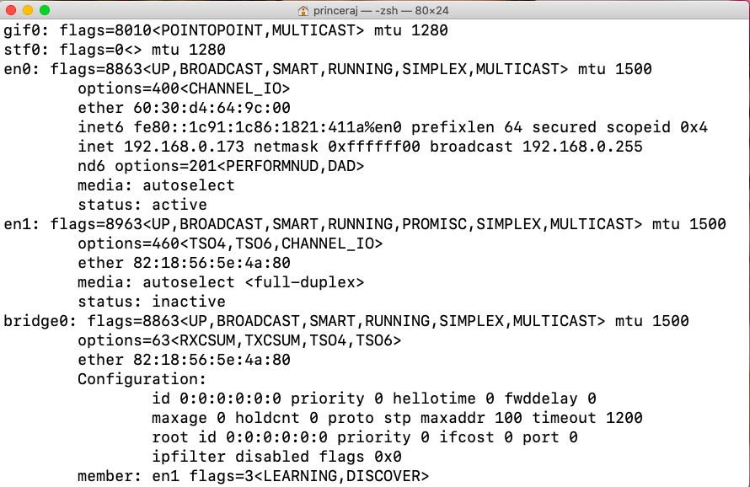

1. traceroute

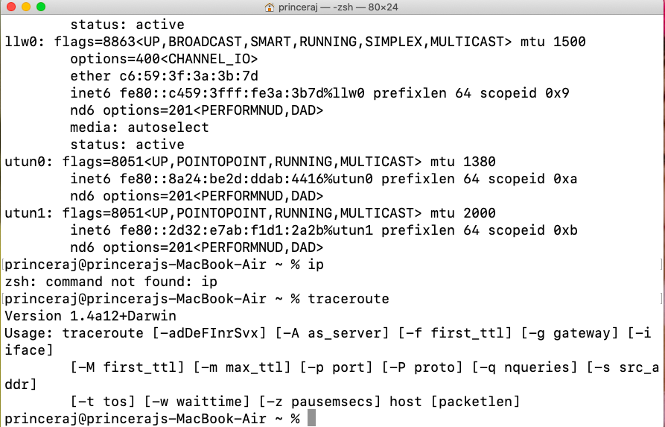

1. ping

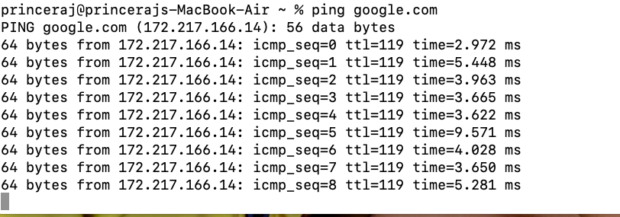

1. netstat

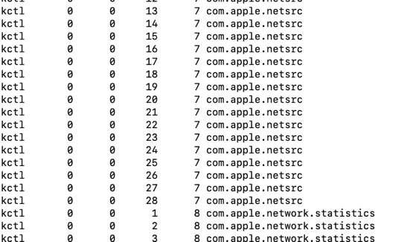

1. dig

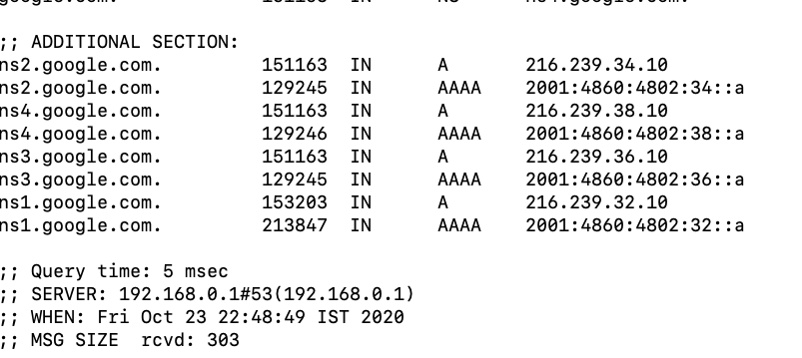

1. Nslookup

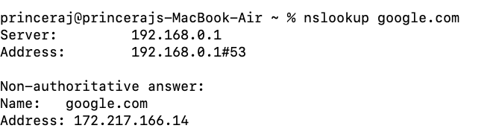

1. whois

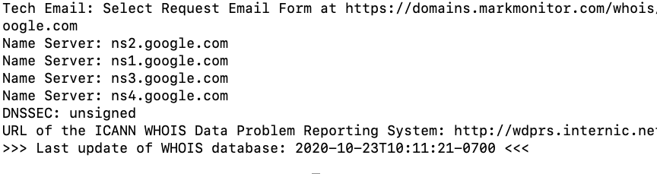

**Experiment – 2**

**Q:- Create a Simple Network Using Packet Tracer**

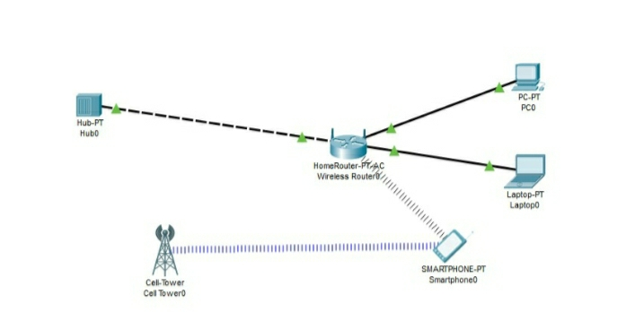

**Experiment – 3**

Basic Router Configuration

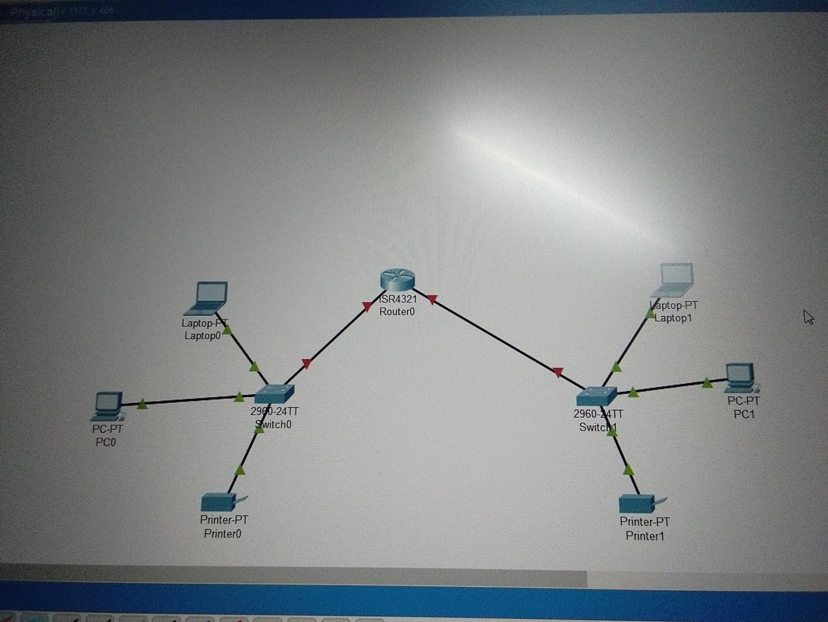

**Experiment – 4**

**Basic Switch Configuration**

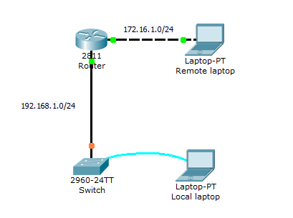

### How to reset switch to factory defaults

During the practice several times we have to reset switch to factory defaults. Make sure you don't run following commands in production environment unless you understand their effect clearly. Following commands will erase all configurations. In production environment you should always takes backup before removing configurations. In LAB environment we can skip backup process.

Switch>enable

Switch#delete flash:vlan.dat

Delete filename [vlan.dat]? [Press Enter Key]

Delete flash:vlan.dat? [confirm] [ Reconfirm by pressing enter key]

Switch#erase startup-config

Switch#reload

### How to set IP address in Switch

IP address is the address of device in network. Switch allows us to set IP address on interface level. IP address assigned on interface is used to manage that particular interface. To manage entire switch we have to assign IP address to VLAN1( Default VLAN of switch). We also have to set default gateway IP address from global configuration mode. In following example we would assign IP *172.16.10.2 255.255.255.0* to VLAN1 and set default gateway to *172.16.10.1*.

Switch>enable

Switch#configure terminal

Switch(config)#interface vlan1

Switch(config-if)#ip address 172.16.10.2 255.255.255.0

Switch(config-if)#exit

Switch(config)#ip default-gateway 172.16.10.1

### How to set interface description

Switches have several interfaces. Adding description to interface is a good habit. It may help you in finding correct interface. In following example we would add description *Development VLAN* to interface *FastEthernet 0/1*.

Switch(config)#interface fastethernet 0/1

Switch(config-if)#description Development VLAN

### How to clear mac address table

Switch stores MAC addresses in MAC address table. Gradually it could be full. Once it full, switch automatically starts removing old entries. You can also clear these tables manually from privileged exec mode. To delete all entries use following command

switch#clear mac address-table

To delete only dynamic entries use

switch#clear mac address-table dynamic

### How to add static MAC address in CAM table

For security purpose sometime we have to add mac address in CAM table manually. To add static MAC address in CAM table use following command

Switch(config)#mac address-table static aaaa.aaaa.aaaa vlan 1 interface fastethernet 0/1

In above command we entered an entry for static MAC address *aaaa.aaaa.aaaa* assigned to *FastEnternet 0/1* with default *VLAN1*.

### How to save running configuration in switch

Switch keeps all running configuration in RAM. All data from RAM is erased when we turned off the device. To save running configuration use following command

Switch#copy running-config startup-config

### How to set duplex mode

Switch automatically adjust duplex mode depending upon remote device. We could change this mode with any of other supported mode. For example to force switch to use full duplex mode use

Switch(config)# #interface fastethernet 0/1

Switch(config-if)#duplex full

To use half duplex use

Switch(config)# #interface fastethernet 0/1

Switch(config-if)#duplex half

### show version

*show version* command provides general information about device including its model number, type of interfaces, its software version, configuration settings, location of IOS and configuration files and available memories.

**Experiment – 5**

BASIC ROUTER CONFIGURATION

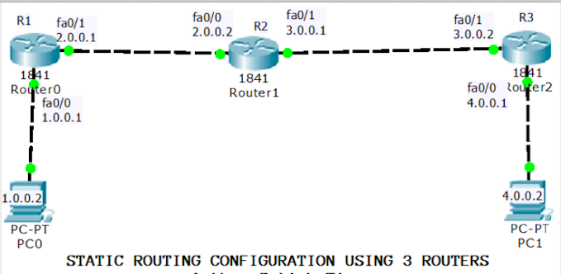

### change default router name

Router (confog) #hostname Lab1

Lab1 (config)#

### Enable telnet access on cisco router

Lab1 (config) #line vty 0 4

Lab1 (config-line) #password 123456

Lab1 (config-line) #login

Lab1 (config-line) #exit

**Secure privilege exec mode with password**

Along with access lines we can also secure privilege exec mode with password. We have two commands to configure the password.

* **Switch(config)# enable password *Privilege_EXEC_password***
* **Switch(config)# enable secret *Privilege_EXEC_password***

### Configure clock time zone

Router allows us to localize the time zone. Following command will set time zone to +5 hour of EST [Eastern Standard Time].

Router(config)#clock timezone EST 05

**Experiment – 6**

Aim:The objective of this experiment is to-

1 Use collaboration tools

1. Share document with Google drive
2. Explore conferencing and web meetings
3. Create wiki page

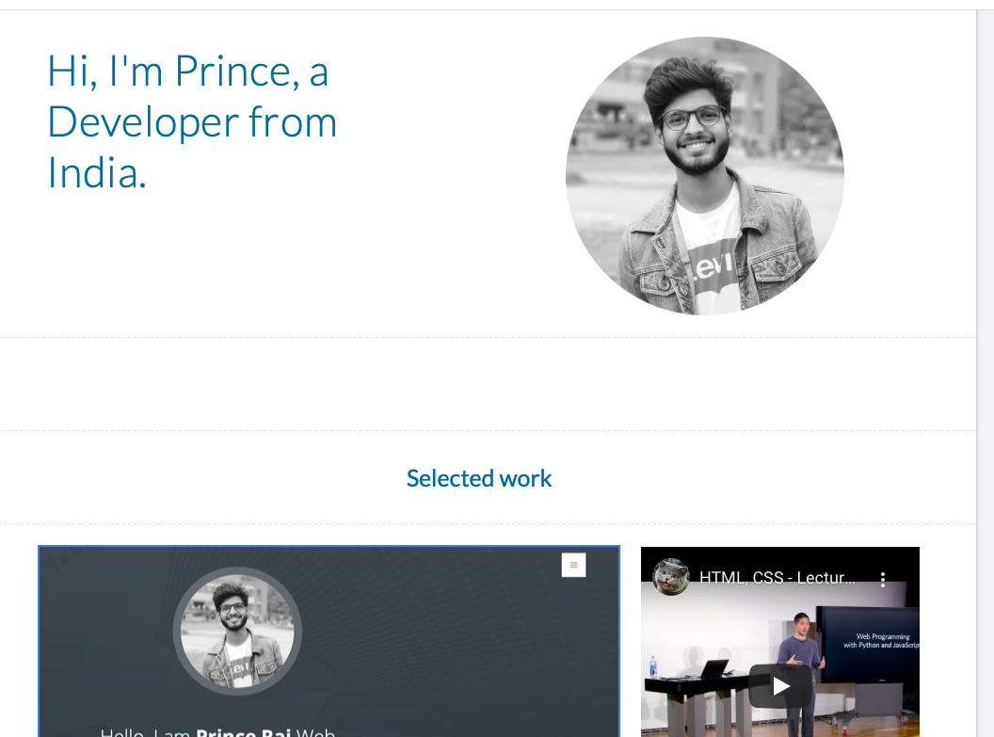

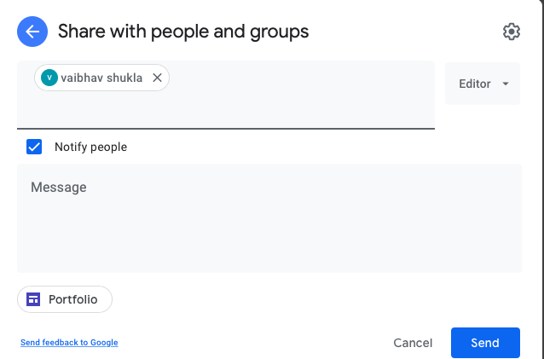

**EXPERIMENT-7**

Connect IOT devices to a registration server

